**The auditory processing, what do we know?**

The auditory processing is an activity which it is done as an involuntary activity by our brain and it gives us environmental information, although this one is integrated much better when the visual system is supporting this acoustic recognition. In fact, in the evolutive development, the sight has a performance more effective around 6th month from the birth, which is really helpful to localization the place of the sound sources and to associating with people, objects and animals. The auditory capacity is necessary to having a right working cognitive either in the early evolutive development, in aging or after a brain damage. From the acoustic wave get in the ear to it arrive in the auditory cortex it suffers a transformation process to the brain can decoded it. Below, we will briefly tell you the “journey” of this wave which it goes to from the ear to the brain cortex.

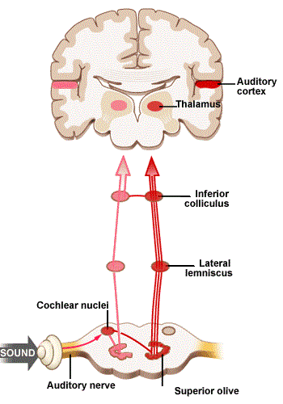

The wave through the pinna and the extern auditory canal towards the tympanic membrane, what it makes this vibrate and it moves the middle ear. This vibration is received by a chain of ossicles (they are the smallest bones our body) and they are formed by malleus, incus and stapes. The latter is joined to the oval window which it has the function of avoid to the wave sound leaving for it. This window is at the beginning in the cochlea and it is going to boosting the pressure waves on the perilymph of the vestibular scale which it makes vibrate the basilar memebrane. This membrane stimulus the hair cells of the organ of Corti where this vibration is transformed in nerve impulses that they are driven to the brainstem through the vestibulocochlear nerve. In the brainstem, these nerve impulses are received by the inferior colliculo and they are projected towards the medial geniculate body (thalamus) and then, they are going to the auditory cortex on the temporal lobes through the auditory radiations.

On the auditory cortex the areas are activating in based of the linguistic and non-linguistic stimuli received and they are processing in a cognitive level to their comprehension and answer. The temporal lobe areas are stimulated with auditory tasks, namely, each specific task produces activation in a specific area. According to several studies of fRMI in healthy subjects the temporal lobe works like a language and complex sounds storage, namely, the sounds which are associated to a referent or meaning. By the other side, these studies also showed the intervention of the frontal lobes in these tasks, signalling as the “motor“ which selects the necessary piece to establish the comprehension of the what we are hearing. But Do we know how the brain is extract, transform and manage this information which it is taken from the nerve impulse? At the moment the is not an explication to this question although we keep working to we will answer it as soon as possible.

Regard the characteristics of the acoustic wave, we know that the speech signal can be analyzed and set up a representation of the different acoustic pattern of the language through of different technologies. However, these software keep showing problems to segment the speech given all phonemics sound are overlapping among them o cause they have difficulties to detecting different accents throughout the talk. In this aspect, the investigation of the neuroscience together to the deep learning, machine learning and artificial intelligence, could help to know how the brain decoded this information, namely, how we analyse the information which gets into through of the nerve impulses with the auditory information. Nonetheless, you have to keep in mind that our brain has deficits, is spite of amazing communication skills which we have developed. An example of that is that the human being are better detecting than discriminating, especially when the difference between stimuli is minimum.

But, how could the society benefit from research about the auditory processing? There are a lot of pathologies which are related to alterations of the central nervous system that it can be only functional deficits or it can be associated to brain damage. The brain injury is one of the pathologies more frequent in the people and the loss of the communication skills is a one of the clinic symptoms more present in these patients. Furthermore, it is not possible create a rehabilitation based in technology to recovery or replace the lost auditory processing skills without a good knowledge about how the cortex auditory works.

Taking into account, we need to know how the brain is processing the auditory information which has been transformed previously in nerve impulses to develop rehabilitation technological systems. In Auditory Cortex, we keep working to achieve these objectives and we will be able to improve the quality of life in people with difficulties in their auditory processing.